The Brisbane Ionian Club

Diary Dates
April ‘’At Home”
Thursday 4th

Committee Meeting
Thursday, 11th April
9.30 AM

Group Activities

MOVIES
Tuesday 9th April

3rd THURSDAY
18th April
Visit to Brisbane City Hall Museum for Easton Pearson Exhibition

16th May
Bus Trip to O’Reilly’s Canungra Valley Vineyard and Township.

FRENCH GROUP

15th April

BOOK GROUP

No April Meeting

WALKING GROUP

No April Walk

HOSTESS
Mary Hayes
e-mail:
athomes@brisbane.
ionians.net
Or phone
0404 995 711

Apologies for April
Tuesday 26th March 10.00am

Email - brisbane@ionians.net
Website - www.brisbane.ionians.net
April 2019 Newsletter
Happiest are those of human race to whom God has given grace
to enjoy, to share, and pray in the true Ionian way

PRESIDENT’S REPORT

At the March At Home, Jessica Reid from Guernsey Adventure Travel spoke to us about growing up in Guernsey and how the success of the movie "Guernsey Literary and Potato Peel Society" inspired her to set up her business. It was a great talk and the meal was delicious. Jessica is happy to make an exclusive Ionian Tour next year, if there is sufficient interest.
The Third Thursday saw 15 of us enjoying good food, wine and company, at the Le Relais Bressan French restaurant in Flaxton. My thanks to Trish Guthrie, Pam Barnes and my Husband, for being drivers and to Julie Anderson, Alison Payne and Rita Donaldson for joining us. It was good fun.

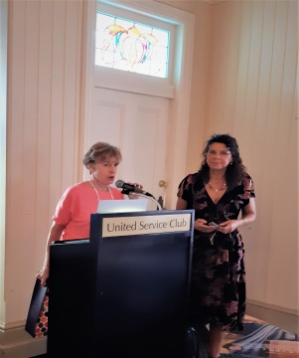 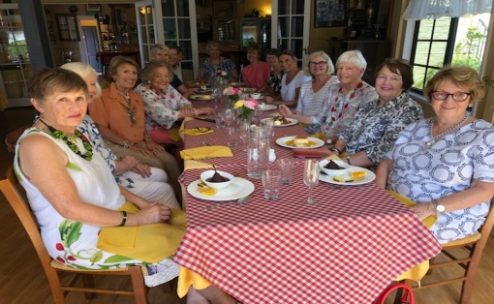
I Iook forward to seeing many of you next month.
Jo
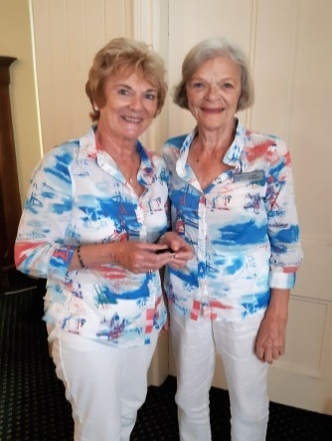
Mary and Jette in February At Home Great Taste!"

“AT HOME” LUNCHES: UNITED SERVICE CLUB
183 WICKHAM TERRACE 10.45AM

“AT HOME” Thursday 4th April.

Our speaker Robi, a Representative from Smart Pups, (dogs trained to help those with autism) will be coming and bringing Miss Daisy who is one of the dogs.

The USC requires that mobile phones are NOT to be used in the Club. Please switch off your phone on entry

______________________________________________________________________________________________

BIRTHDAYS FOR APRIL

16th Julie Anderson, 17th Peg Green, 25th Jette Andersen and Betty Tudberry.

Diary Dates

MOVIE GROUP - Tuesday, 9th April - Graceville Regal Twin Cinemas

Details will be announced during the April At Home
If you are not at the luncheon you may obtain details by contacting Margot 3255 8877

BOOK GROUP

There will be no meeting in April due to Anzac Day.
The May meeting will be held at Kay Rees’ home.

General enquiries Margo 3255 8877

FRENCH GROUP - 15th April
The next meeting will be held at Alex Robinson’s home.

General enquiries contact Fay 3899 4610

WALKING GROUP Next Meeting 17th May

No walk in April due to Easter and people away.

May Walk 17th May - Meet Dana McCown at 56 Wharf Street. The walk will go through the Kangaroo Point parks and then along the river ending up at South Bank. After some refreshments, the choice will be to catch the free ferry back to Kangaroo Point or those feeling the need for some more exercise can walk over the bridge and back through the city to the Story Bridge.
Please complete the sign-up sheet at the April meeting.

Please contact Dana if attending. 3217 3552 or dana.mccown98@gmail.com

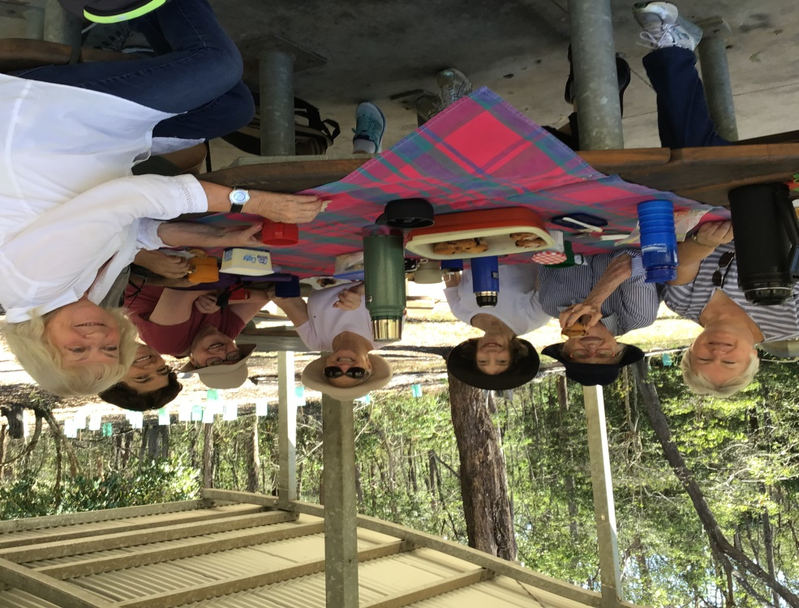

Fun was had by all on this easy walk, and a delicious snack was provided by Jacqui and George consisting of Coffee, Tea and Muffins.
Those taking the walk and enjoying the half way repast were:
Dana, Helen, Bernice, Alex, Jacqui, Dot, and Dot’s Sister Mary from Germany.

DINING OUT - 17th April

The venue for Wednesday, 17th April is Paw Paw Café, cnr. Stanley St. & Potts St. Wollongabba.
It is open from 5.30pm but we will try for a 6.00pm start.

THEATRE OUTING

Jan Frewin will organise tickets for SCHOOL OF ROCK for 7th August at 1.00pm.
The cost will be $80 or $70 for concessions.
Please let Jan know if you are interested – payment must be by 25th April.

THIRD THURSDAY 18th April

Visit to the Brisbane City Hall Museum to see the Easton Pearson Exhibition. We will meet at 10.30am. After, at 11.30am, lunch will be at the Goldfinch Restaurant, Corner of Ann and Roma Street, opposite City Hall. The cost for the exhibition is $12 ($9 concession). Payment made directly at the museum. See sign-up sheet.

OTHER CLUBS

Adelaide ’83 Club is selling Rose Cards which were fundraisers for the Adelaide and Newcastle conventions. Pam is ordering 6 sets for our Club. Members to contact Pam if they wish to purchase them.

GENERAL INFORMATION ABOUT ‘AT HOMES’ LUNCHEONS
Unless advised otherwise - United Service Club, 183, Wickham Terrace
10.45 for 11.00 am.

PAYMENT DETAILS
Cost: $50
Payable by: Cash, Cheque or Electronic Transfer
* Cash and cheques in an envelope with your name and details of each payment clearly written on the outside please.
Postal payments:
Loretta Stasi, 36 Samba Place, Underwood 4119
Cheques payable to: The Brisbane Ionian Club
For EFT: -
Acc Name: The Brisbane Ionian Club Inc.
Bank: CBA - King George Square Branch
BSB: 064-001 Account No.: 0094-1687
Payee Ref: Your name and details of the deposit

APOLOGIES & ACCEPTANCES

If you apologise by voice message or email please ensure you have an acknowledgement of your message, by phone or email, before the cut-off date.
If you know in advance, sign the Apologies Book at the ‘At Home’ Lunch.

To telephone/email your apology, bring a guest, or if you are an Associate wishing to attend, please contact:

Mary Hayes: athomes@brisbane.ionians.net or by phone 0404 995 711

PLEASE NOTE THE CUT OFF DATE FOR APOLOGIES FOR THE MARCH “AT HOME” TUESDAY 26th FEBRUARY 10AM .

Ordinary Members are assumed to be attending unless an apology is received

Attendance by Associate Members and Guests must be advised. Please be aware that if you are an Ordinary Member and do not put in an apology in time, the cost of $50 will be forwarded on to you as charged by the venue.

BIC Review Workshop Response Form

Your feedback and ongoing participation are very important in this review process so could you please provide any comments on the workshop report, and any additional ideas and actions for consideration:

Member Name (optional) -----------------------

Options for submitting your response:
- Email: brisbane@ionians.net (Committee and ex-officio will receive this)
- Hand in at April ‘At Home’
- Mail to Secretary : Paulette Archer, PO Box 269, Hamilton 4007
- Phone: President Jo Mellor 3374 2325 or 0404 001 812
Review co-ordinator Rita Donaldson 0423 222 727

